Physical design.pdf: a berif intorduction of the algorithm
Pyhsical design.ppt: the pre slide
Run runme.sh
Or run the comand in the terminal like this:
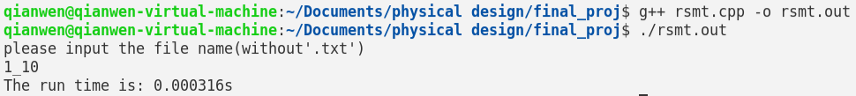
The output is two files:
- :1_10_steiners : the list of steiner points in the RSMT
- :1_10_edges:the list of the edges of the RSMT
Type into “2_50”, ”3_100”, “4_150”, “5_200”
You will get similar two files.

